GUEST OF THE MONTH/March 2025
Haik Movsesian – Supervisor of Distribution Planning - LADWP

UPDATE ON PLANNED POWER SYSTEM DISTRIBUTION SYSTEM UPGRADES

By Robert Yoshimura

Haik Movsesian’s presentation on LADWP’s plans for distribution system upgrades needed to accommodate the anticipated growth in demand focused primarily on forecasting future demands and determining the impact of those demands on distribution system capacity. Such forecasting is a currently ongoing exercise intended to define future infrastructure needs and operating strategies for inclusion in the Strategic Long Term Resources Plan which in turn is intended to assure a reliable power distribution system in the future.
The power distribution system is the last part of the power system network of facilities needed to provide power to the customer. The process begins with generation from gas/coal/nuclear-fueled thermal power plants, hydroelectric generation, wind turbines, geothermal facilities, and solar power generation facilities. Such power is delivered at high voltages (approximately 138 to 500 kV or more) via the power transmission system to Receiving Stations (RCs). The RCs reduce voltage to 34.5 kV and deliver that power either directly to large customers (greater than 300 kW of demand) or to one of many Distribution Stations (DSs) located within Los Angeles. The DSs further reduce voltage to 4.8 kV and deliver that power to small industrial/commercial customers or to pole-top transformers for distribution to residential customers at 240/120 V.
The current distribution system consists of 20 RSs, 532 circuits carrying 34.5 kV power, 126 DSs, and 1617 circuits carrying 4.8 kV power. A significant challenge in forecasting future capacity is the need to analyze the impacts on each of these facilities 20 years into the future for several different demand scenarios. Additionally, distribution load forecasting is 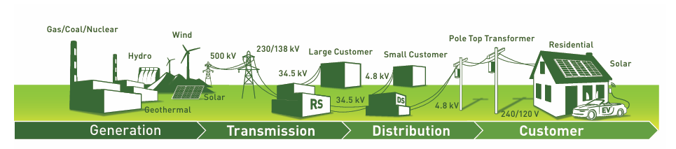
complicated by the large number of factors (load modifiers) that affect load growth such as climate, building growth rate, new interconnections, and electrification of cars, trucks, and buildings. It is further complicated by the need to consider factors that reduce load such as roof-top solar, energy storage, and energy conservation strategies.
Building growth rate is determined from recent data which shows residential growth of between zero and one percent per year. Energy use growth is then calculated from that data and used to determine building growth effect on energy demand. Major electrification loads from large facilities such as LAX, the Port of LA, Hyperion Water Reclamation Plant, Data Centers, and Metro are estimated using data from the responsible agencies.

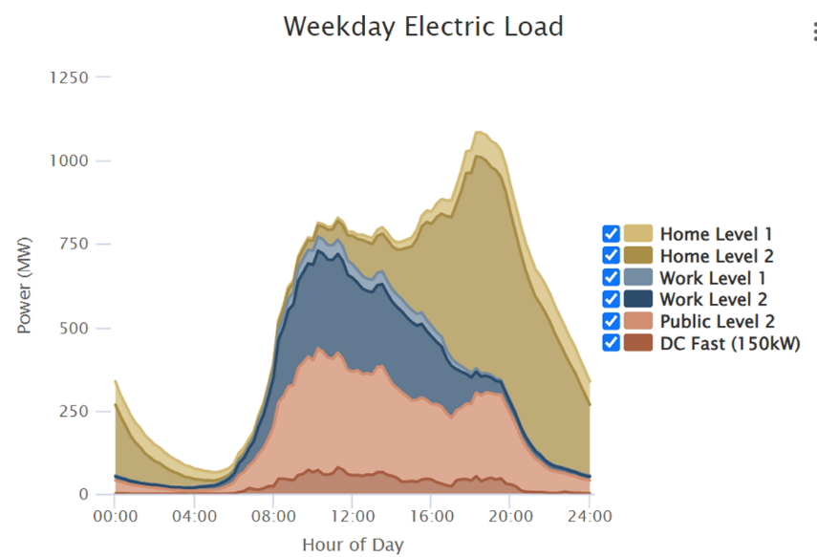
Light duty EV (cars) growth rates are estimated from Department of Motor Vehicles data and predicts that the number of electric cars in Los Angeles will increase from 200,000 today to 1.4 million in 2035. Data from the National Renewable Energy Laboratory is then used to determine the additional energy demand resulting from charging those cars (see adjacent figure for 2035). Subsequently, the location and number of public charging stations is estimated based on the locations of apartments where residents are less likely to charge their vehicles at home. Electric vehicles are the single most significant load modifier in these studies.
Heavy duty EVs (trucks) are not expected to grow as quickly as cars until after 2035 but will have an impact on load at that time. The existing movements of trucks are tracked to identify likely locations where they will be charged to determine the need for distribution station and feeder line upgrades. The location and growth of roof-top solar installations are also estimated to determine load reduction impacts throughout the city.
The impacts of all the load modifiers are used to determine the net load on the distribution system in each of the next 20 years. Four scenarios are used to determine load growth under varying assumptions. A “best guess” baseline scenario is supplemented by three likely outcomes including Low (fewer EVs than expected plus more solar than expected), High (More EVs than expected), and High Managed (load shifting applied to time and location of EV charging in High scenario). The High Managed scenario results in a significantly lower peak load than either the baseline or the High scenarios and presents an optimistic strategy for the future.
Recommendations from this study are as follows:
- Equitably prioritize and address distribution system needs to maintain reliability while supporting future electrification demands.
- Optimize residential EV charging through strategic rate design and tailored charging programs.
- Modernize and automate the grid to accommodate higher penetration of Distributed Energy Resources.
- Pair solar and storage to better align with the shifting distribution system peak.
- Expand customer programs to address location-specific distribution system challenges.

